**# Alon Rasehlbach, Ofer Fassler**

**# Spring 2017**

**# Technion EE Lab 1**

**BMP file to MIF file python script**

**Prerequisites:**

Install **python 2.7.13** from: <https://www.python.org/downloads/>

Add python to path : during installation choose – add python.exe to path

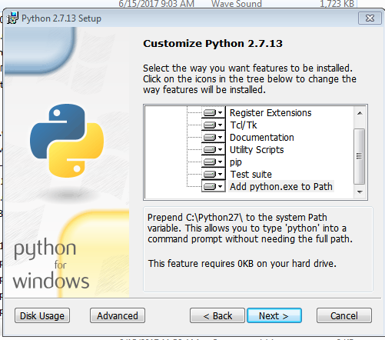

Open cmd and install pillow by writing:

pip install pillow

**Usage:**

1. Save BMP image with pixel depth of 8 bit
2. Run <script.py> “ImagePath” “OutputPath”
3. Enter the image pixel numbers in powers of 2 (eg. For image of 100x100 enter 14 – because 12^14 is 16K)
4. The output file is MIF file. You can load it to Quartus using the MegaWizard toolkit.